Media Playbook: How to Cover Electoral Conflict

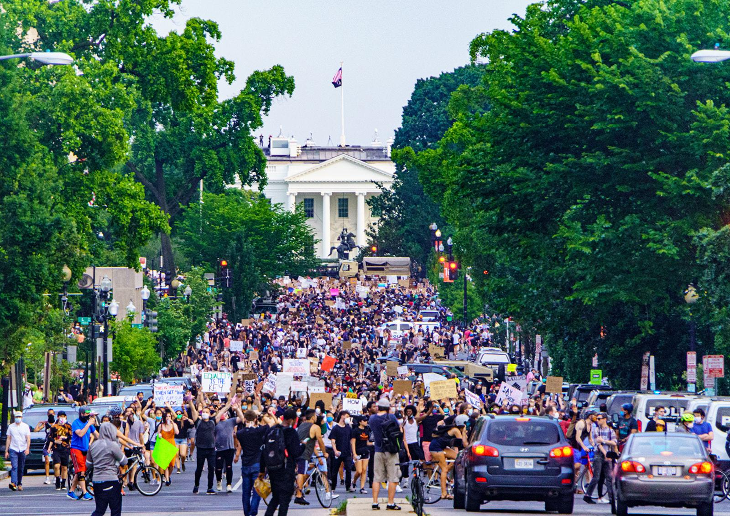
Credit: Ted Eytan, MD

By Amanda Ripley and Rachel Kleinfeld

The 2020 election feels unprecedented in the United States. Nearly three out of four Americans are worried there will be widespread violence in response to the results, according to More in Common. Protests, racial discord and the pandemic have aggravated anxiety and suspicion in a nation already under strain.

But journalists have covered elections similar to this, all over the world, for many years. They’ve agonized over their mistakes and learned from their best coverage. They’ve created playbooks for covering contested elections in frayed societies.

The US is different from other countries in many ways. But polarized people tend to behave similarly, all over the world. And in this context, the usual traditions of journalism will not work—and can do enormous harm.

“For me, when I read stories from the United States now, it’s like a flashback. Like a movie I’m watching again,” says Patricia Torres, a veteran journalist in Venezuela. “Violence is violence, everywhere. Polarization is also the same. It’s a human thing. It’s important for journalists to understand that.”

Here are 10 lessons US journalists can learn from reporters abroad to better serve the public in the days ahead.

- Do Saturation Coverage of the Voting Process, in Advance

- Set Expectations

- Reach Out to Crisis Sources Now

- Denormalize Violence

- Complicate the Narrative

- Include Context, Every Time

- Rehumanize Americans

- Reject Violent Metaphors & Headlines

- Beware of Rumors

- Feature People Getting Things Right

Before the Election:

- Do Saturation Coverage of the Voting Process, in Advance

“The run-up to the election is almost more important than the election,” says Zafar Sobhan, editor-in-chief of the Dhaka Tribune in Bangladesh. “People need to understand the rules of the game.”

Tense elections can become violent if people feel processes are illegitimate--or if people feel helpless. The United States has many processes in place for managing election problems. But the rules vary from place to place, and most people don’t understand them.

Investigate and explain the rules and procedures in your community—and in swing states. Does a ballot have to be received or just postmarked by Election Day? Does your state require a witness for a mail-in ballot? (For the basics, 538.com’s Voting Guide is a good resource; for knotty questions, contact the National Task Force on Election Crises. )

Ask audiences to submit their own questions about the election. Consider making the person who submitted the question a protagonist in the story, as WBEZ in Chicago often does with its Curious City series. Americans have a lot more agency than people in many other polarized nations, and it’s important to show it in action.

Cover efforts to solve electoral problems, not just the problems. For ideas, check out the Solution Journalism Network’s story tracker, which includes hundreds of stories on the upcoming election like this Wall Street Journal piece about how South Korea managed a national election during the pandemic.

No election is perfect, but the United States has been holding elections for almost 250 years, during wartime and peace. We have a long history of smooth and contested elections. Bureaucratic snafus do not always signal intentional suppression or fraud. Now is a good time to look back at problems that have occurred in past elections, including the most recent primary seasons, and explain how they were resolved.

- Set Expectations:

Explain early and often that final vote counts may take a week or more and that a time lapse does not equal a “delay.” Delay connotes a problem. In our system, votes can be counted up until the December 8 “safe harbor” elector deadline. We’re used to seeing results earlier, but a longer wait this year may mean more mail-in ballots, not a failure of democracy.

Americans will likely be inundated with conflicting analysis of the results in real time. Now is the time to introduce audiences to poll-watching laws and election-integrity organizations that may become important sources of clarity after election day.
Expect more lawsuits, and tell your audiences to expect them, too. Litigation has become predictable in recent presidential elections, and it will be even more common this year due to voting alterations spurred by the pandemic. Lawsuits are not inherently a cause for alarm.

- Reach Out to Crisis Sources Now:

In Burundi, gunmen began firing on voters in one town during an election in 2005. They wanted to create chaos to suppress turnout, and it looked, initially like they might succeed. Rumors swirled that many polling stations had been attacked and that the election was being canceled. A network of journalists, working together across different outlets, quickly checked with sources on the ground, who confirmed that the violence was isolated and the election had not been canceled. The rest of the election continued in relative peace.

Election violence is often sparked by rumors, spread via social media, and amplified by journalists. To avoid becoming part of the problem, journalists need to act fast through a broad, pre-existing network of sources.

“Highly escalated, stressful situations are a terrible time to make new friends,” says Mike Jobbins at Search for Common Ground, which works on preventing violence in 36 countries. “Now is the moment for building those relationships.”

Establish (or Revive) Lines of Communication with:

- Election officials, candidates, and other party officials, including partisan and non-partisan poll watchers
- Politicians at all levels
- Local police and sheriff departments
- National Guard public affairs office in your state
- Local Black Lives Matter leaders
- Militia leaders in your area
- Local protest leaders
- Trusted community leaders (including local clergy and business leaders)

“It’s like how we prepare for extreme weather risks,” says Rachel Brown, founder of Over Zero and author of the guidebook Defusing Hate. “We strengthen the infrastructure: you work on building relationships, setting strong norms, supporting those affected. Those things help you regardless of what happens.”

- Denormalize Violence

The research is encouraging on this. Words matter. Leaders—and even regular people – can prevent bloodshed by condemning violent behavior.

More than 800 people were killed in election violence in Nigeria in 2011. In the lead up to the 2015 election, a pop star known for his love songs led a public campaign for peace, reminding everyone that “elections are not war.” Calls to “vote not fight” were echoed by media publishers and chambers of commerce, which had strong economic interests in keeping the peace. The two main presidential candidates urged supporters to refrain from violence. That election was one of the most peaceful in the country’s history.

In a hyperpolarized country, the news media has a civic responsibility to broadcast statements condemning violence far and wide. Amplify quotes from influential people willing to speak strongly against hateful language and actions (as Virginia’s Republican leadership did before a large gun rights rally, warning that “Any group that comes to Richmond to spread white supremacist garbage, or any other form of hate, violence, or civil unrest isn’t welcome here.”)

Share and repeat any forceful condemnations of violence – all kinds of violence, against property and against people – from pundits, business leaders, clergy, celebrities, and politicians and party officials, at the national, state, and particularly the local level (where trust in government is highest).

Give special attention to quotes that are surprising, beyond banal calls for “civility.” It’s especially powerful to quote leaders calling out their own partisans for bad behavior, as Fox News did in this story about Joe Biden’s condemnation of Antifa violence. These within-group admonishments tend to be the most influential in limiting violence.

- Complicate the Narrative:
Framing everything as a win-lose contest between two sides flattens your story and deepens polarized identities. Instead, spotlight disagreements within groups, for example, the New York Times story on political tensions within a tight-knit group of US military veterans.

Use precise language—especially in headlines. Don’t describe all Republicans or all Democrats as one united bloc. It’s not accurate. Avoid a partisan descriptor when a more specific description will do. Interview militia members or protesters and identify their organization by name, rather than referring to groups on the “right” or “left.” Don’t assume you can identify them by the way they look. Make clear that violent individuals are on the fringes, outside the mainstream of their party, and they represent a tiny fraction of the American population. Consider invoking the “we” of Americans whenever relevant.

Don’t just repeat what you are told. In Venezuela, critics of the news media call this syndrome “declaracionitis.” Don’t just declare that people are in conflict; explain why they are. Get curious. Ask deeper questions. Why are some people refusing to follow public-health guidance? What do they believe? Emphasize the hopes, frustrations and fears beneath the usual talking points.

Explain the historical context. This National Geographic project looked backwards to help understand the 2020 protests: “Starting in 1919, three major waves of nationwide uprisings in the 20th century shed light on how the fight for racial equality has grown, how it’s changed, and what has stayed the same.”

Remember that our divisions are not limited to racial or partisan differences. Acknowledge the effects of the pandemic. Many people are cut off from social support, anxious, out of work or dealing with kids not in school. Return repeatedly to the profound distrust pervading American life, which leaves our society vulnerable.

During and After the Election:

- Include Context, Every Time:

In many African countries, news outlets have learned to create large networks of journalists working in multiple locations to contextualize election day footage. “One journalist cannot make a difference,” says Joseph Jimmy Sainkaituah, director of Search for Common Ground’s work in Sierra Leone and Liberia. “You need a network to facilitate coordination.” Instead of focusing on one single polling place with long lines or violence, for example, they make the rounds on a “multiplex” of polling places. This way, the audience gets a sense of the good, the bad and the ugly.

Without that perspective, people will be more frightened and alarmed than reality requires. Frightened people make bad decisions. Between May 24 and August 22, there were more than 10,600 demonstration events across the country. Demonstrators committed acts of violence in about 5% of these protests, according to the US Crisis Monitor. But that sense of proportion was missing in much of the coverage. Anyone watching Fox News, for example, had to conclude that broad swaths of the country were descending into anarchy.

In any polarized country, journalists should use images of chaos and violence with care, in proportion to their actual relevance. Put every frightening story in perspective. Always include the denominator. If there are long lines at certain polling places, what percentage of voters are likely affected? If there is looting or violence, how widespread is it? How does the estimated damage compare to, say, the economic damage caused by other incidents, such as a past hurricane?

To keep a sense of perspective in the weeks to come, check this ecosystem map by the Bridging Divides Initiative for real-time updates on protests and violence, alongside links to community groups who can provide context in each place.

- Rehumanize Americans

Americans hold distorted views about their political opponents. And the more news they consume, the more wrong they are.

Reminding Americans of the actual demographics and opinions of average voters can help correct these distortions. Most Republicans and Democrats are white, middle-class heterosexuals. A majority of Democrats and Republicans believe voting, education and healthcare are “essential” rights, according to a July 2020 poll. A majority of both groups believe racial diversity makes the country stronger. Most Americans are fed up by political polarization and 81% say it is essential that all Americans accept valid election results, regardless of who wins.

When Americans hear more accurate information about their opponents, they tend to feel less hostility for one another, researchers have found. Telling the truth, in other words, reduces the odds of political violence.

Recognize the biases in your audience and yourself. Dig deeper to get a more accurate, nuanced sense of what is motivating all sides.

- Reject Violent Metaphors & Headlines

Even mildly violent word choices, such as “Lawyers will fight against election changes” have been shown to normalize violence. Don’t amplify the rhetoric of politicians or pundits who use the language of “enemies,” “mobs” and “war.” Dehumanizing language can give people permission to commit acts of violence.

It is not necessary to run a story every time someone of dubious influence uses hateful speech. In normal times, that is just lazy. In hyper-polarized times, it’s journalistic malpractice.

If a story about incendiary language is newsworthy, don’t repeat the language in the headline. And seek out quotes condemning violence from the same side. That is a more accurate representation of the variance within existing groups.

- Beware of Rumors:

Violence often begins with rumors. These rumors don’t need to be true to kick off a cycle of revenge violence. In time, frightened voters turn to strong-men leaders who promise to restore safety—even as they restrict freedoms. This pattern occurs all over the world. America is not exempt.

The best way to investigate a rumor is to see what is happening on the ground. If you cannot do so, wait. “If you’re an ethical journalist, you have to be slow,” says Sobhan at the Dhaka Tribune. “You have to train people to hold their horses.”

Don’t repeat misinformation, even to debunk it. The brain equates repetition with truth. Instead, state true information and if necessary, refer to the misperception, conspiracy, or rumor without restating the falsehood.

- Feature People Getting Things Right:
How did a local election clerk fight disinformation? How did Portland avoid confrontations between Proud Boys and BLM protestors? Good news stories tell people that their actions matter. By showing that there are still nonviolent paths forward, they defuse violence.
In talk show formats, remember to showcase what mature disagreement looks like. Feature thoughtful conversations where people show genuine curiosity about one another, even as they continue to profoundly disagree.

The Current Moment

This is a dangerous time for American democracy. In the past four months, more than 69 drivers have plowed into peaceful protesters around the country. Federal judges are being threatened at significantly higher rates than just five years ago.
When democracies grow troubled, they rely on the news media to play a civic role that goes beyond their usual business models and traditions. In addition to reporting the facts and enlightening the audience, the news media has a responsibility, in this climate, to cover conflict with great care and avoid inciting additional violence.

This guide was informed by Search for Common Ground, Ross Howard’s “Conflict Sensitive Journalism,” the Solutions Journalism Network and the work of many researchers, particularly, Elizabeth Paluck, Nour Kteily, Emile Bruneau, Nathan Kalmoe, Lilliana Mason and Nealin Parker. For more, we recommend Over Zero’s report Building U.S. Resilience to Political Violence: A (Globally-Informed) Framework.

10 Tactics for Covering Electoral Conflict

(Without Making It Worse)

- Do Saturation Coverage of the Voting Process, in Advance

- Set Expectations

- Reach Out to Crisis Sources Now

- Denormalize Violence

- Complicate the Narrative

- Include Context, Every Time

- Rehumanize Americans

- Reject Violent Metaphors & Headlines

- Beware of Rumors

- Feature People Getting Things Right

